**4.STOCK MAINTAINANCE SYSTEM**

USECASE DIAGRAM:

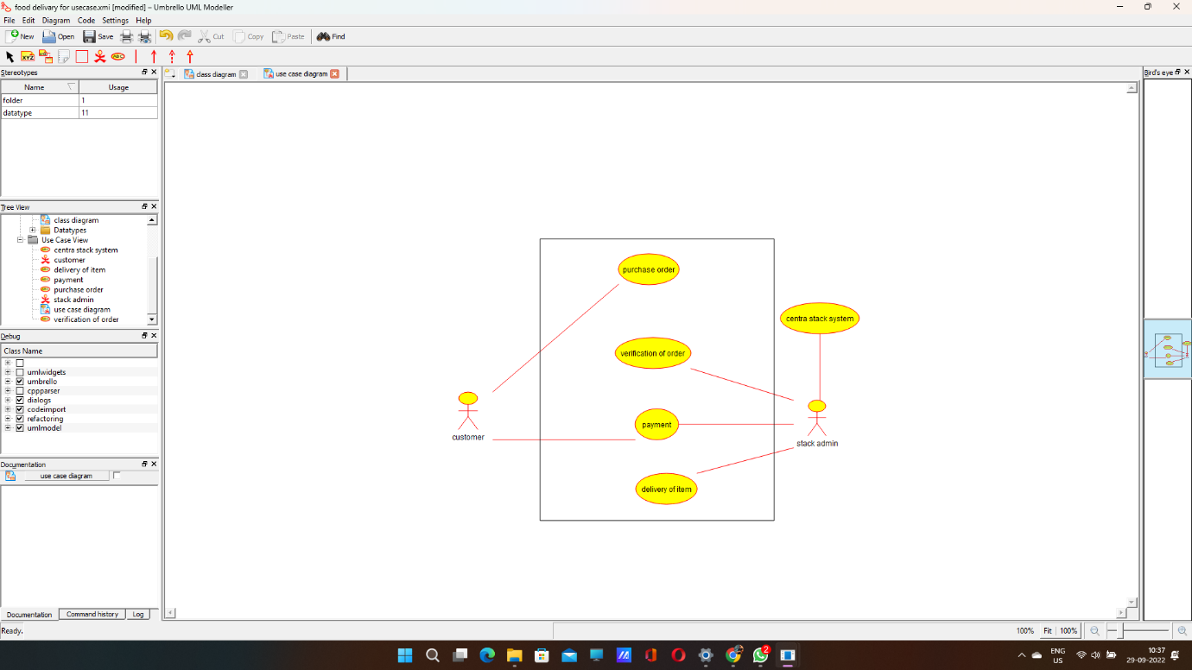

CLASS DIAGRAM:

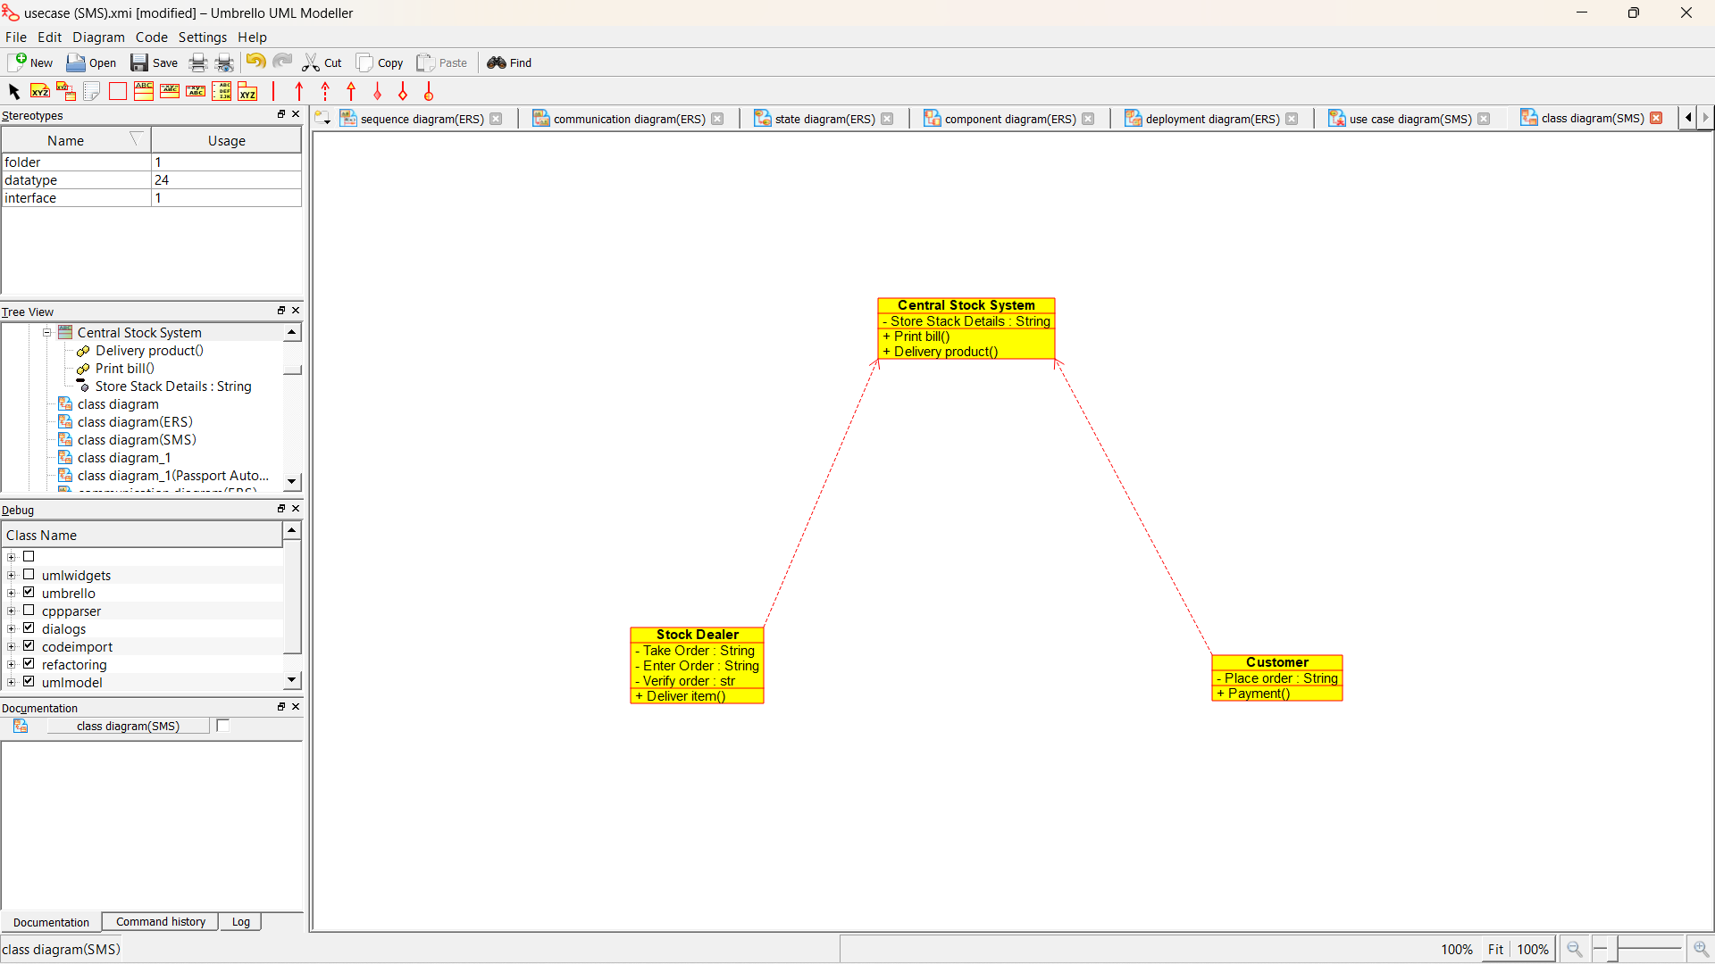

ACTIVITY DIAGRAM:

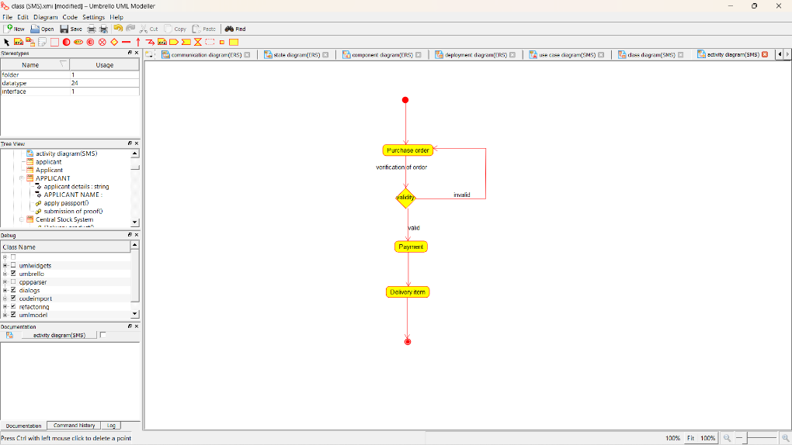

SEQUENCE DIAGRAM:

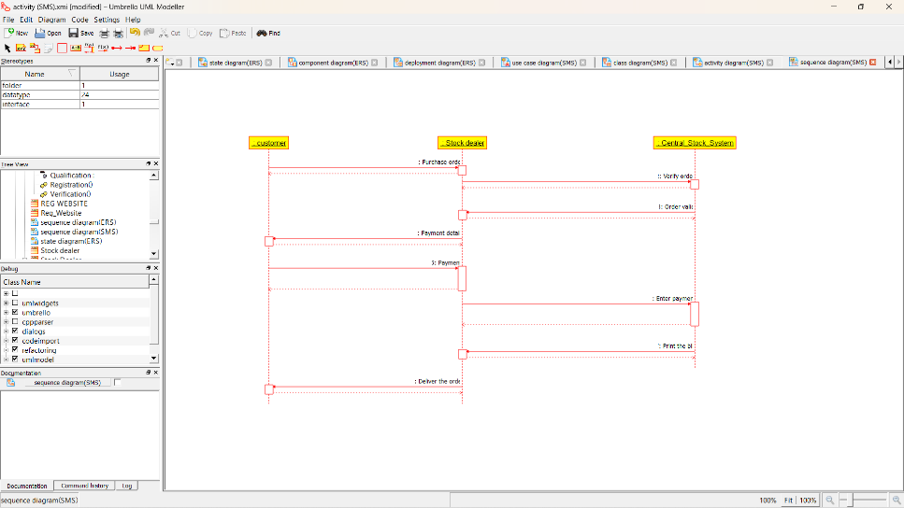

COLLABORATION DIAGRAM:

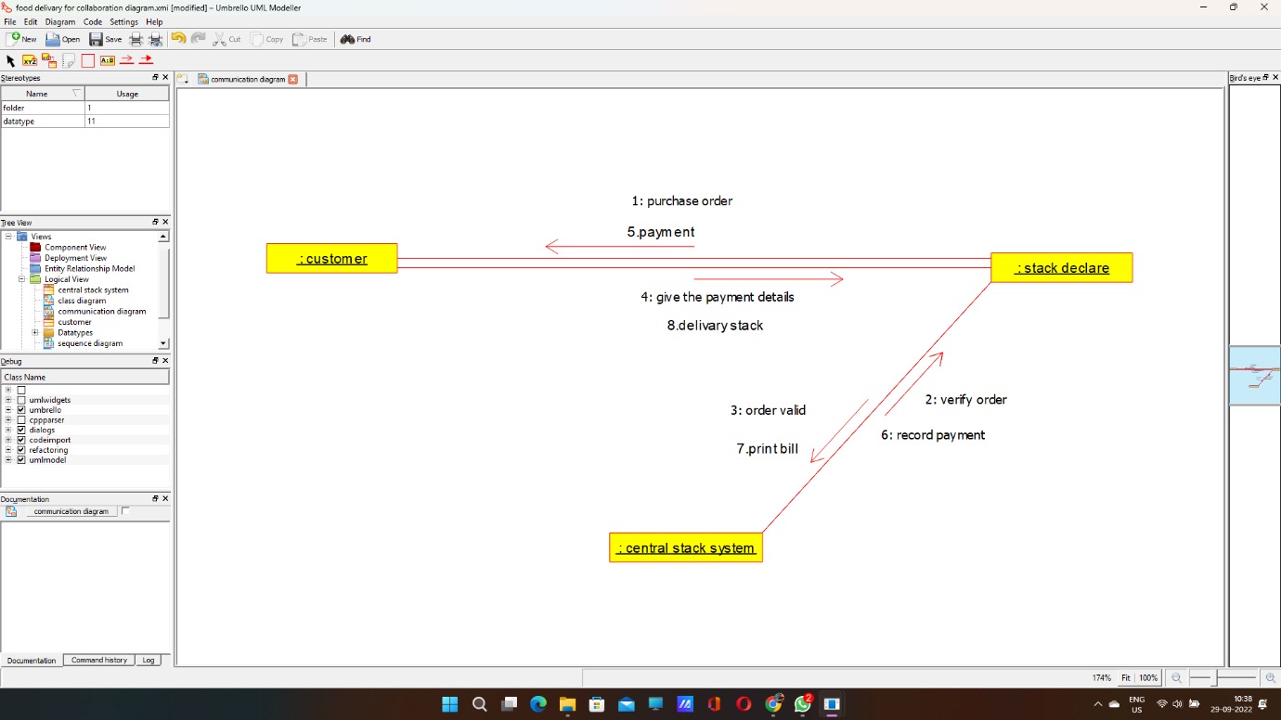

STATE DIAGRAM:

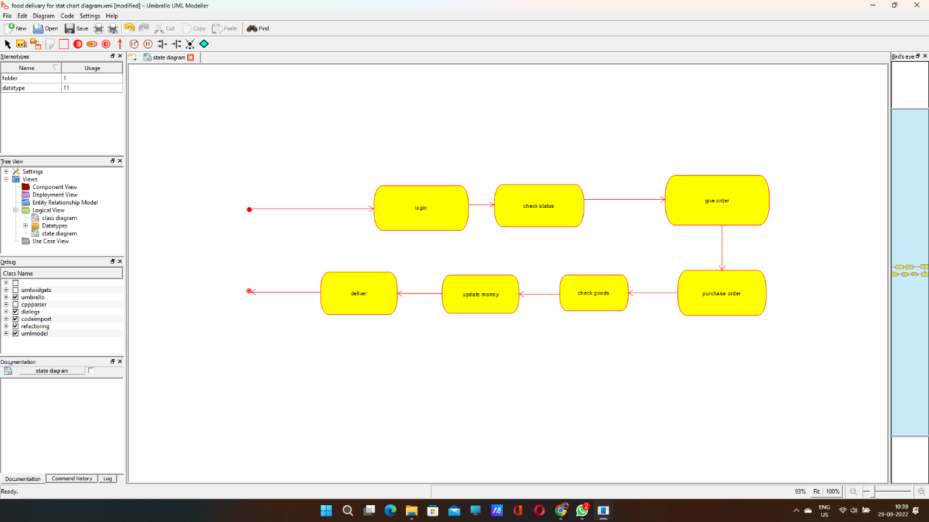

COMPONENT DIAGRAM:

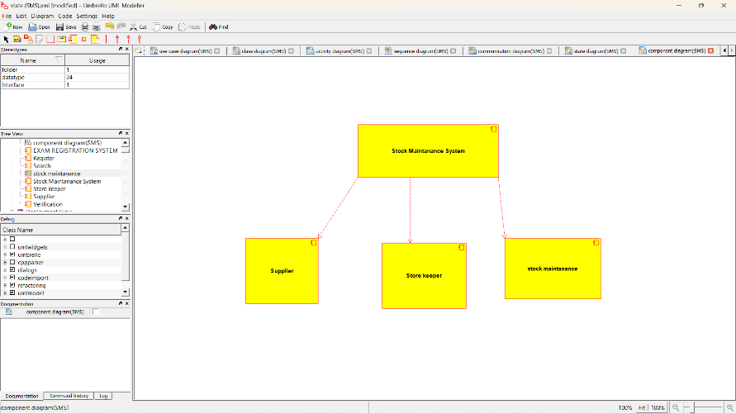

DEPLOYMENT DIAGRAM:

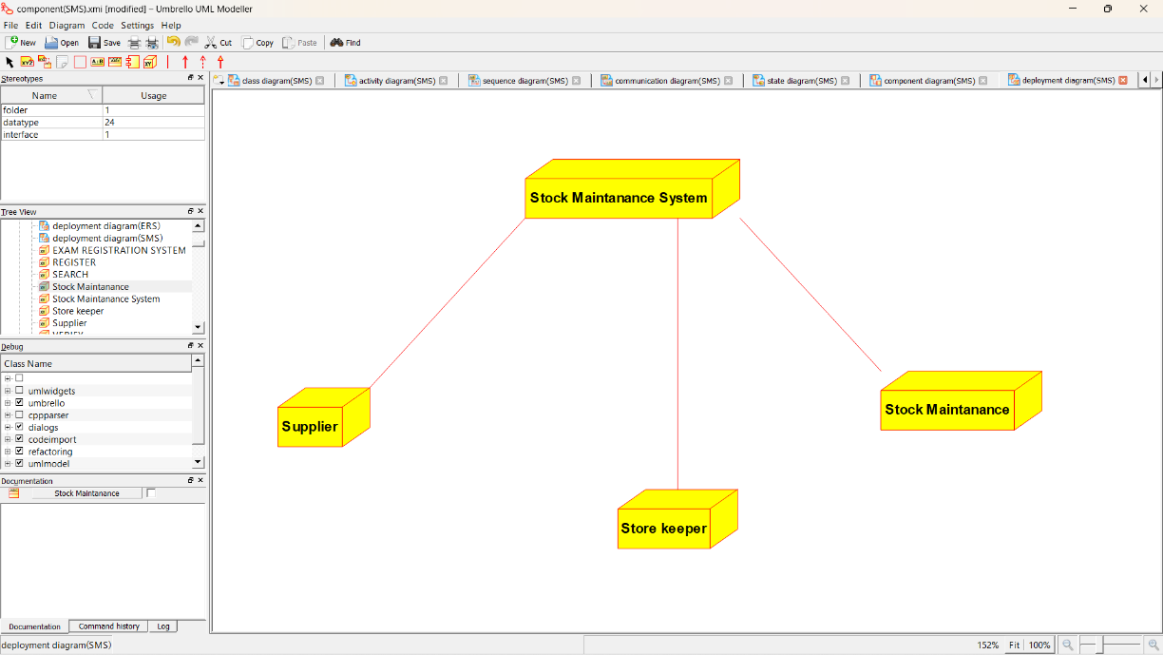

*PROGRAM CODING:*

/**

* Class Central_Stock_System

*/

public class Central_Stock_System {

//

// Fields

//

private String Store_Stack_Details;

//

// Constructors

//

public Central_Stock_System () { };

//

// Methods

//

//

// Accessor methods

//

/**

* Set the value of Store_Stack_Details

* @param newVar the new value of Store_Stack_Details

*/

private void setStore_Stack_Details (String newVar) {

Store_Stack_Details = newVar;

}

/**

* Get the value of Store_Stack_Details

* @return the value of Store_Stack_Details

*/

private String getStore_Stack_Details () {

return Store_Stack_Details;

}

//

// Other methods

//

/**

*/

public void Print_bill()

{

}

/**

*/

public void Delivery_product()

{

}

}

/**

* Class Stock_Dealer

*/

public class Stock_Dealer {

//

// Fields

//

private String Take_Order;

private String Enter_Order;

private str Verify_order;

//

// Constructors

//

public Stock_Dealer () { };

//

// Methods

//

//

// Accessor methods

//

/**

* Set the value of Take_Order

* @param newVar the new value of Take_Order

*/

private void setTake_Order (String newVar) {

Take_Order = newVar;

}

/**

* Get the value of Take_Order

* @return the value of Take_Order

*/

private String getTake_Order () {

return Take_Order;

}

/**

* Set the value of Enter_Order

* @param newVar the new value of Enter_Order

*/

private void setEnter_Order (String newVar) {

Enter_Order = newVar;

}

/**

* Get the value of Enter_Order

* @return the value of Enter_Order

*/

private String getEnter_Order () {

return Enter_Order;

}

/**

* Set the value of Verify_order

* @param newVar the new value of Verify_order

*/

private void setVerify_order (str newVar) {

Verify_order = newVar;

}

/**

* Get the value of Verify_order

* @return the value of Verify_order

*/

private str getVerify_order () {

return Verify_order;

}

//

// Other methods

//

/**

*/

public void Deliver_item()

{

}

}

/**

* Class Customer

*/

public class Customer {

//

// Fields

//

private String Place_order;

//

// Constructors

//

public Customer () { };

//

// Methods

//

//

// Accessor methods

//

/**

* Set the value of Place_order

* @param newVar the new value of Place_order

*/

private void setPlace_order (String newVar) {

Place_order = newVar;

}

/**

* Get the value of Place_order

* @return the value of Place_order

*/

private String getPlace_order () {

return Place_order;

}

//

// Other methods

//

/**

*/

public void Payment()

{

}

}